Experiment No 1
Title: Demonstrate inline, internal, and external JavaScript; use console methods; create a webpage showing user info and a welcome message.
Software/Tools Required: HTML5, CSS3, JavaScript, Visual Studio Code, Google Chrome
<!DOCTYPE html>
<html lang="en">
<head>
<meta charset="UTF-8">
<meta name="viewport" content="width=device-width, initial-scale=1.0">
<title>JavaScript Demonstration</title>

<style>
body{
margin:0;
font-family:Arial, Helvetica, sans-serif;
background:linear-gradient(135deg,#6a11cb,#2575fc);
display:flex;
justify-content:center;
align-items:center;
height:100vh;
}

.container{
width:420px;
background:rgba(255,255,255,0.18);
backdrop-filter:blur(12px);
border-radius:15px;
padding:25px;
text-align:center;
color:white;
box-shadow:0 10px 25px rgba(0,0,0,.3);
}

h1{
margin-bottom:20px;
}

p{
font-size:18px;
margin:10px 0;
}

button{
padding:12px 20px;
margin:10px;
border:none;
border-radius:8px;
cursor:pointer;
background:#00c6ff;
color:white;
font-size:16px;
transition:.3s;
}

button:hover{
background:#0072ff;
}

#welcome{
margin-top:20px;
font-size:20px;
font-weight:bold;
color:#ffff99;
}
</style>

</head>

<body>

<div class="container">

<h1>JavaScript Demonstration</h1>

<p><b>Name:</b> Shubhanshu Manjare</p>

<p><b>PRN:</b>24070521170</p>

<p><b>Department:</b> Computer Science & Engineering</p>

<p><b>College:</b> Symbiosis Institute of Technology</p>

<!-- Inline JavaScript -->
<button onclick="alert('Hello! Welcome to JavaScript.')">
Inline JavaScript
</button>

<!-- Internal JavaScript -->
<button onclick="showMessage()">
Internal JavaScript
</button>

<!-- External JavaScript -->
<button onclick="displayWelcome()">
External JavaScript
</button>

<div id="welcome"></div>

</div>

<script>

function showMessage(){

document.getElementById("welcome").innerHTML =
"✅ This message is displayed using Internal JavaScript.";

console.log("Console Log Example");
console.info("Console Info Example");
console.warn("Console Warning Example");
console.error("Console Error Example");

}

</script>

<script src="script.js"></script>

</body>
</html>
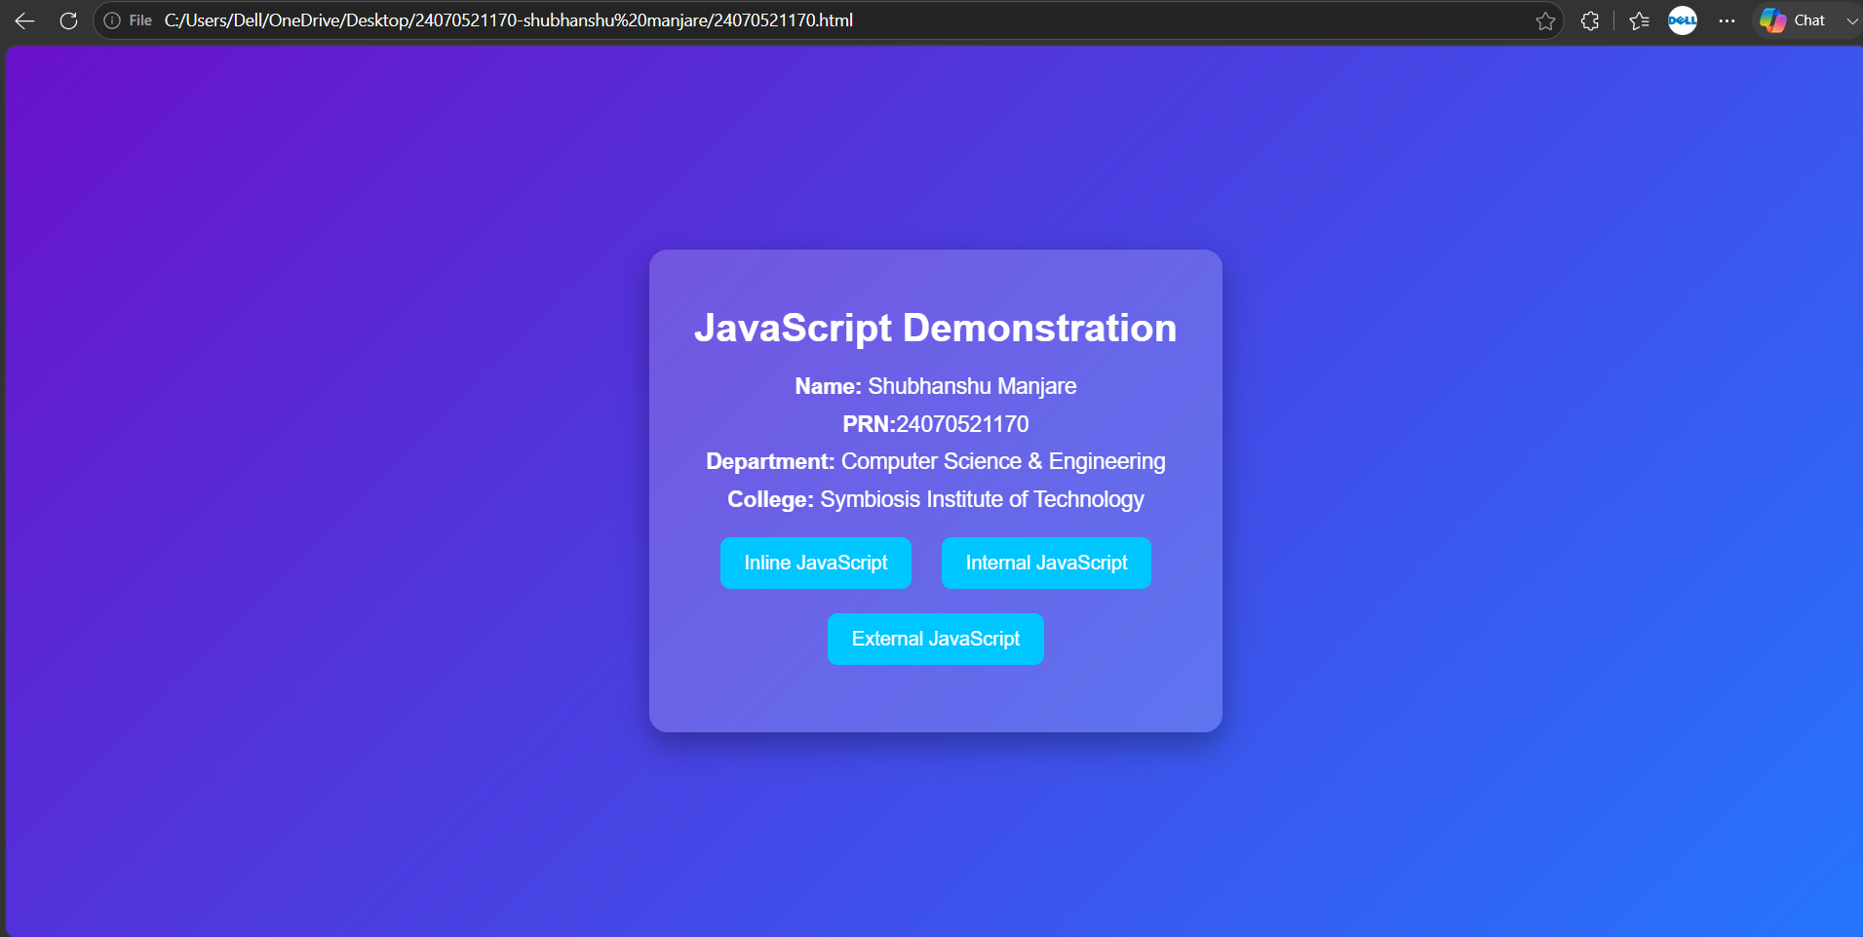

CaseStudy_1
Case Study No.: 1
Title: Create a webpage for college department and link the student information page with it and write a JavaScript program to display "Welcome to SIT Nagpur" in an alert box.
Software/Tools Required: HTML5 , CSS3 , JavaScript , Visual Studio Code , Google Chrome
Student.html
<!DOCTYPE html>
<html lang="en">
<head>
<meta charset="UTF-8">
<meta name="viewport" content="width=device-width, initial-scale=1.0">
<title>Student Information</title>
<style>
*{
margin:0;
padding:0;
box-sizing:border-box;
font-family:Arial, Helvetica, sans-serif;
}
body{
background:linear-gradient(135deg,#0f2027,#203a43,#2c5364);
min-height:100vh;
display:flex;
justify-content:center;
align-items:center;
padding:30px;
}
ontainer{
width:90%;
max-width:950px;
background:rgba(255,255,255,0.12);
backdrop-filter:blur(15px);
-webkit-backdrop-filter:blur(15px);
border-radius:20px;
border:1px solid rgba(255,255,255,0.2);

padding:35px;
box-shadow:0 8px 30px rgba(0,0,0,.4);
animation:fadeIn 1s;
}
h1{
text-align:center;
color:white;
margin-bottom:10px;
}
p{
text-align:center;
color:#ddd;
margin-bottom:25px;
}
table{
width:100%;
border-collapse:collapse;
overflow:hidden;
border-radius:10px;
}
th{
background:#00b4d8;
color:white;
padding:15px;
}
td{
padding:15px;
background:rgba(255,255,255,0.15);
color:white;
text-align:center;
}
tr:nth-child(even) td{
background:rgba(255,255,255,0.08);
}
tbody tr{
transition:.3s;
}
tbody tr:hover{
background:rgba(0,180,216,.4);
transform:scale(1.01);
}
.back-btn{
display:inline-block;
margin-top:25px;
text-decoration:none;

background:#00b4d8;
color:white;

padding:12px 20px;
border-radius:30px;

transition:.3s;
}

.back-btn:hover{

background:#0096c7;
transform:translateY(-3px);
box-shadow:0 5px 15px rgba(0,180,216,.5);
}

@keyframes fadeIn{

from{
opacity:0;
transform:translateY(20px);
}

to{
opacity:1;
transform:translateY(0);
}

}

@media(max-width:700px){

table{
font-size:14px;
}

th,td{
padding:10px;
}

.container{
padding:20px;
}

}

</style>
</head>
<body>
<div class="container">
<h1>🎓 Student Information Directory</h1>

<p>Below is the list of students enrolled in the Computer Science Department.</p>
<table>
<thead>
<tr>
<th>Roll Number</th>
<th>Name</th>
<th>Year</th>
<th>Email</th>
</tr>
</thead>
<tbody>
<tr>
<td>CS101</td>
<td>Alice Smith</td>
<td>3rd Year</td>
<td>alice@college.edu</td>
</tr>

<tr>
<td>CS102</td>
<td>Bob Jones</td>
<td>2nd Year</td>
<td>bob@college.edu</td>
</tr>

<tr>
<td>CS103</td>
<td>Charlie Brown</td>
<td>4th Year</td>
<td>charlie@college.edu</td>
</tr>

<tr>
<td>CS104</td>
<td>David Wilson</td>
<td>1st Year</td>
<td>david@college.edu</td>
</tr>

<tr>
<td>CS105</td>
<td>Emma Watson</td>
<td>3rd Year</td>
<td>emma@college.edu</td>
</tr>

</tbody>

</table>
<center>
<a href="department.html" class="back-btn">⬅ Back to Department Home</a>
</center>
</div>
</body>
</html>
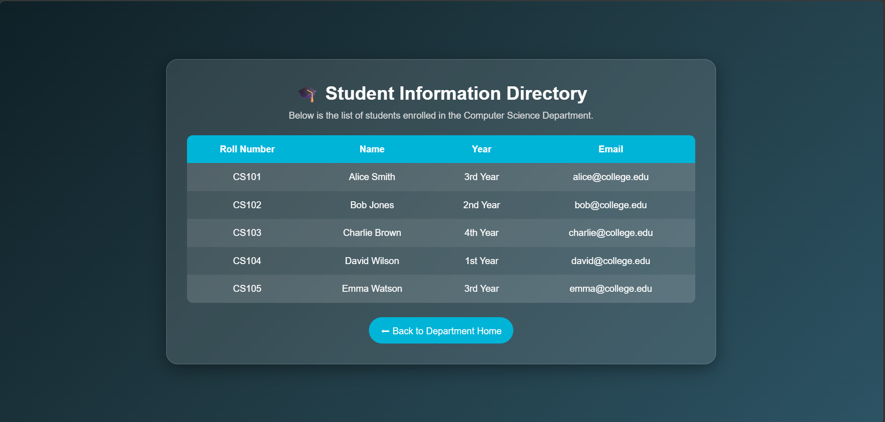

Department.html
<!DOCTYPE html>
<html lang="en">
<head>
<meta charset="UTF-8">
<meta name="viewport" content="width=device-width, initial-scale=1.0">
<title>Computer Science Department</title>
<link rel="stylesheet" href="style.css">
</head>
<body>
<header>
<h1>Symbiosis Institute of Technology</h1>
<p>Nagpur Campus</p>
</header>

<nav>
<a href="department.html">Home</a>
<a href="student_info.html">Student Information</a>
</nav>

<div class="container">
<h2>Computer Science & Engineering Department</h2>
<p>The Computer Science and Engineering Department provides quality education in Programming, Artificial Intelligence, Data Science, Cyber Security, Cloud Computing and Software Development.</p>

<h3>Vision</h3>
<p>To develop skilled engineers with technical knowledge, innovation, leadership and ethical values.</p>

<h3>Mission</h3>
<ul>
<li>Provide quality education.</li>
<li>Encourage research and innovation.</li>
<li>Develop problem-solving skills.</li>
<li>Prepare students for industry.</li>
</ul>

<a href="student_info.html" class="btn">View Student Information</a>
</div>

<script src="script.js"></script>
</body>
</html>

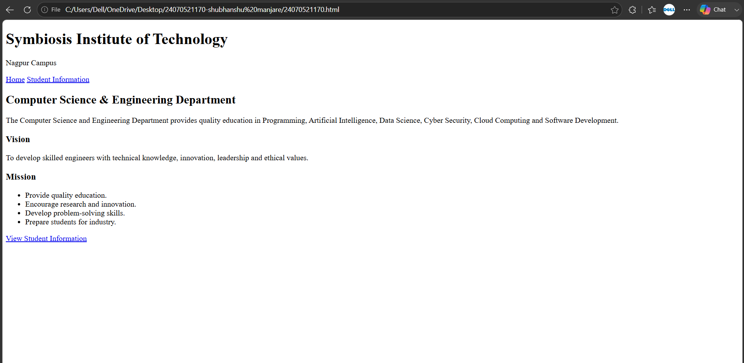

Experiment 2
Use var, let, const, and demonstrate basic features like template literals and destructuring; build a billing calculator with user input.
<!DOCTYPE html>
<html>
<head>
<title>Popup Bill Generator</title>
</head>
<body>

<script>
// 1. Take inputs from the user using popup boxes
var uName = prompt("Enter User Name:");
var contact = prompt("Enter Contact No:");
var pName = prompt("Enter Product Name:");
var qty = prompt("Enter Quantity:");
var price = prompt("Enter Price per Unit:");

// Convert string inputs to numbers for calculation
qty = Number(qty);
price = Number(price);

// 2. Perform calculations
var total = qty * price;
var gst = total * 0.18;
var finalAmount = total + gst;

// 3. Display the layout using document.write
document.write("<h2>Bill Details</h2>");

// Left Half: Details Box
document.write("<div style='width: 45%; float: left; border: 2px solid black; padding: 15px; box-sizing: border-box;'>");
document.write("<h3>Enter Details</h3>");
document.write("<p><b>User Name:</b><br>" + uName + "</p>");
document.write("<p><b>Contact No:</b><br>" + contact + "</p>");
document.write("<p><b>Product Name:</b><br>" + pName + "</p>");
document.write("<p><b>Quantity:</b><br>" + qty + "</p>");
document.write("<p><b>Price per Unit:</b><br>" + price + "</p>");
document.write("</div>");

// Right Half: Receipt Box
document.write("<div style='width: 45%; float: left; border: 2px solid black; padding: 15px; margin-left: 5%; box-sizing: border-box;'>");
document.write("<h3>Bill Receipt</h3>");
document.write("<p>User Name: " + uName + "</p>");
document.write("<p>Contact No: " + contact + "</p>");
document.write("<p>Product Name: " + pName + "</p>");
document.write("<p>Quantity: " + qty + "</p>");
document.write("<p>Price: " + price + "</p>");
document.write("<hr>");
document.write("<p>Total Value: " + total + "</p>");
document.write("<p>GST (18%): " + gst + "</p>");
document.write("<p><b>Final Amount: " + finalAmount + "</b></p>");
document.write("<br>");
document.write("<p>Name: Shubhanshu Manjare , PRN: 24070521170</p>");
document.write("</div>");
</script>

</body>
</html>
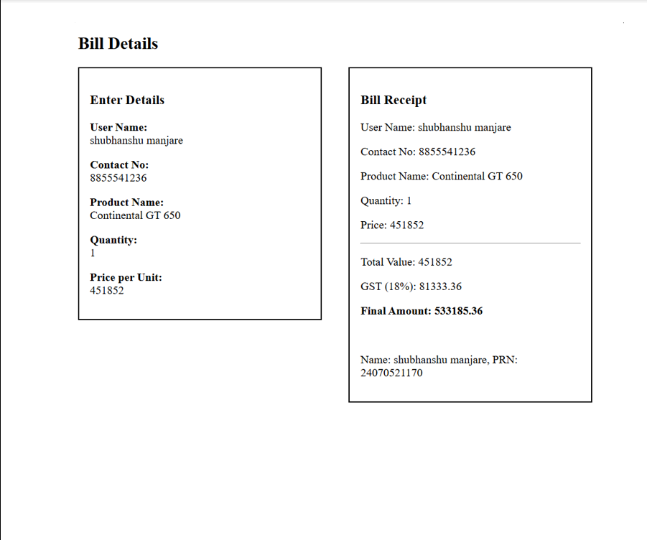

CaseStudy 2
Title: Develop the webpage for an online shopping website with using HTML,CSS and HTML5 tags and calculate the bill using Customer Name, Mobile number, Invoice Number, Product Name, Quality (in Kgs), Rate per Kg(Rs), Discount(%), GST(%), Packing Charges(Rs), Payment Mode (Cash/Card/UPI).
Software/Tools Required: HTML5 , CSS3 , JavaScript , Visual Studio Code , Google Chrome

<!DOCTYPE html>
<html lang="en">
<head>
<meta charset="UTF-8">
<meta name="viewport" content="width=device-width, initial-scale=1.0">
<title>Online Shopping Bill Calculator</title>
<link rel="stylesheet" href="style.css">
</head>
<body>

<div class="container">
<h1>🛒 Online Shopping Bill Calculator</h1>

<form id="billForm">

<div class="row">
<div class="input-box">
<label>Customer Name</label>
<input type="text" id="customer" placeholder="Enter Customer Name" required>
</div>
<div class="input-box">
<label>Mobile Number</label>
<input type="tel" id="mobile" placeholder="Enter Mobile Number" required>
</div>
</div>

<div class="row">
<div class="input-box">
<label>Invoice Number</label>
<input type="text" id="invoice" value="INV2026-001">
</div>
<div class="input-box">
<label>Product Name</label>
<input type="text" id="product" placeholder="Enter Product Name" required>
</div>
</div>

<div class="row">
<div class="input-box">
<label>Quantity (Kg)</label>
<input type="number" id="qty" min="1" value="1">
</div>
<div class="input-box">
<label>Rate per Kg (₹)</label>
<input type="number" id="rate" value="100">
</div>
</div>

<div class="row">
<div class="input-box">
<label>Discount (%)</label>
<input type="number" id="discount" value="5">
</div>
<div class="input-box">
<label>GST (%)</label>
<input type="number" id="gst" value="18">
</div>
</div>

<div class="row">
<div class="input-box">
<label>Packing Charges (₹)</label>
<input type="number" id="packing" value="20">
</div>
<div class="input-box">
<label>Payment Mode</label>
<select id="payment">
<option>Cash</option>
<option>Card</option>
<option>UPI</option>
</select>
</div>
</div>

<button type="button" onclick="generateBill()">Generate Bill</button>

</form>

<div id="bill">
<h2>Invoice</h2>

<table>
<tr><td>Customer Name</td><td id="bname"></td></tr>
<tr><td>Mobile Number</td><td id="bmobile"></td></tr>
<tr><td>Invoice Number</td><td id="binvoice"></td></tr>
<tr><td>Product Name</td><td id="bproduct"></td></tr>
<tr><td>Quantity</td><td id="bqty"></td></tr>
<tr><td>Rate / Kg</td><td id="brate"></td></tr>
<tr><td>Subtotal</td><td id="bsubtotal"></td></tr>
<tr><td>Discount</td><td id="bdiscount"></td></tr>
<tr><td>GST</td><td id="bgst"></td></tr>
<tr><td>Packing Charges</td><td id="bpacking"></td></tr>
<tr><td>Payment Mode</td><td id="bpayment"></td></tr>
<tr class="total"><td>Final Amount</td><td id="btotal"></td></tr>
</table>

</div>
</div>

<script src="script.js"></script>

</body>
</html>

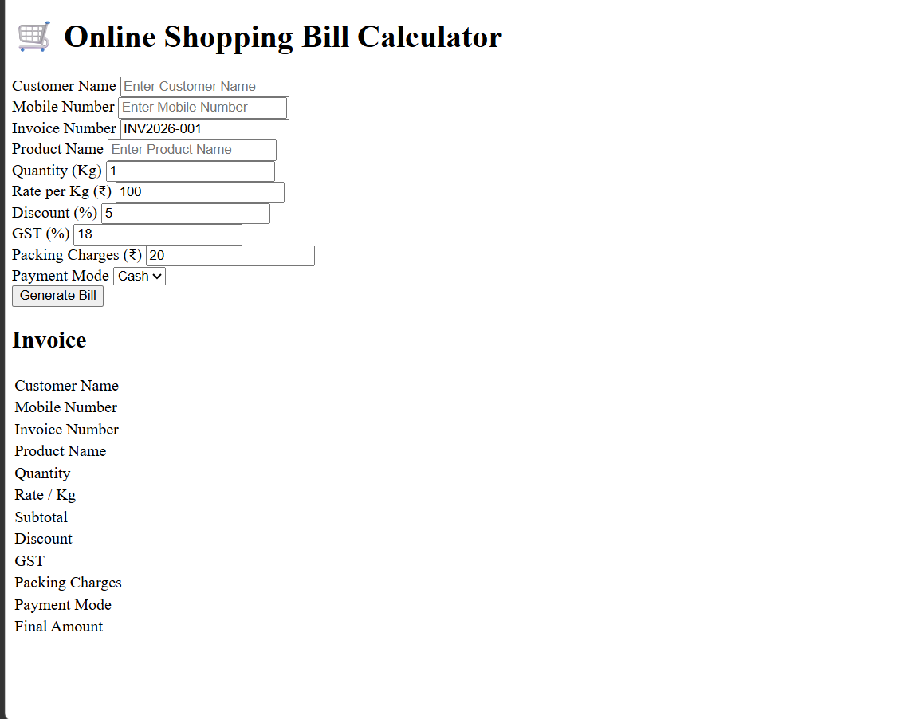

Experiment 3
Title: Implement control structures and form validation; create a grading system based on user-entered marks.
Software/Tools Required: HTML5, CSS3, JavaScript, VS Code, Google Chrome
<!DOCTYPE html>
<html lang="en">
<head>
<meta charset="UTF-8">
<meta name="viewport" content="width=device-width, initial-scale=1.0">
<title>5-Subject Grading System</title>
<style>
* { box-sizing: border-box; font-family: system-ui, -apple-system, sans-serif; }
body { background-color: #f4f6f9; display: flex; justify-content: center; align-items: center; min-height: 100vh; margin: 0; padding: 1.5rem; }
.card { background: #ffffff; padding: 2rem; border-radius: 12px; box-shadow: 0 4px 16px rgba(0,0,0,0.08); width: 100%; max-width: 480px; }
h2 { margin-top: 0; color: #1e293b; text-align: center; }
.grid { display: grid; grid-template-columns: 1fr 1fr; gap: 0.75rem 1rem; }
.form-group { margin-bottom: 0.75rem; }
.full-width { grid-column: span 2; }
label { display: block; margin-bottom: 0.35rem; font-weight: 600; color: #334155; font-size: 0.9rem; }
input[type="number"] { width: 100%; padding: 0.65rem; border: 1px solid #cbd5e1; border-radius: 6px; font-size: 0.95rem; }
input[type="number"]:focus { outline: none; border-color: #2563eb; box-shadow: 0 0 0 3px rgba(37,99,235,0.15); }
button { width: 100%; padding: 0.75rem; background-color: #2563eb; color: white; border: none; border-radius: 6px; font-size: 1rem; font-weight: 600; cursor: pointer; margin-top: 0.5rem; transition: background 0.2s; }
button:hover { background-color: #1d4ed8; }
.error-banner { background-color: #fef2f2; border-left: 4px solid #ef4444; color: #991b1b; padding: 0.75rem; border-radius: 4px; font-size: 0.875rem; margin-bottom: 1rem; display: none; }
.result-box { margin-top: 1.25rem; padding: 1.25rem; border-radius: 8px; display: none; }
.result-header { font-size: 1.1rem; font-weight: 700; margin-bottom: 0.5rem; text-align: center; }
.result-details { font-size: 0.95rem; line-height: 1.5; }
/* Dynamic Theme Colors */
.grade-A { background-color: #dcfce7; color: #166534; border: 1px solid #bbf7d0; }
.grade-B { background-color: #e0f2fe; color: #075985; border: 1px solid #bae6fd; }
.grade-C { background-color: #fef9c3; color: #854d0e; border: 1px solid #fef08a; }
.grade-D { background-color: #ffedd5; color: #9a3412; border: 1px solid #fed7aa; }
.grade-F { background-color: #fee2e2; color: #991b1b; border: 1px solid #fca5a5; }
</style>
</head>
<body>

<div class="card">
<h2>Student Assessment</h2>

<!-- Unified Error Banner -->
<div id="errorBanner" class="error-banner"></div>

<form id="gradeForm" novalidate>
<div class="grid">
<div class="form-group">
<label for="sub1">Mathematics</label>
<input type="number" id="sub1" class="subject-input" placeholder="0 - 100">
</div>
<div class="form-group">
<label for="sub2">Science</label>
<input type="number" id="sub2" class="subject-input" placeholder="0 - 100">
</div>
<div class="form-group">
<label for="sub3">English</label>
<input type="number" id="sub3" class="subject-input" placeholder="0 - 100">
</div>
<div class="form-group">
<label for="sub4">History</label>
<input type="number" id="sub4" class="subject-input" placeholder="0 - 100">
</div>
<div class="form-group full-width">
<label for="sub5">Computer Science</label>
<input type="number" id="sub5" class="subject-input" placeholder="0 - 100">
</div>
</div>
<button type="submit">Calculate Final Results</button>
</form>

<div id="resultBox" class="result-box">
<div id="resultHeader" class="result-header"></div>
<div id="resultDetails" class="result-details"></div>
</div>
</div>

<script>
document.getElementById('gradeForm').addEventListener('submit', function(e) {
e.preventDefault();

const inputs = document.querySelectorAll('.subject-input');
const errorBanner = document.getElementById('errorBanner');
const resultBox = document.getElementById('resultBox');
const resultHeader = document.getElementById('resultHeader');
const resultDetails = document.getElementById('resultDetails');

// Reset UI state
errorBanner.style.display = 'none';
resultBox.style.display = 'none';
resultBox.className = 'result-box';

const scores = [];
let hasFailedSubject = false;

// --- 1. CONTROL STRUCTURE: Loop with Validation Checks ---
for (let i = 0; i < inputs.length; i++) {
const value = inputs[i].value.trim();
const label = inputs[i].previousElementSibling.textContent;

// Check empty input
if (value === '') {
showError(`Please fill in marks for <strong>${label}</strong>.`);
inputs[i].focus();
return;
}

const score = Number(value);

// Check invalid numbers or out-of-bounds inputs
if (isNaN(score) || score < 0 || score > 100) {
showError(`Invalid mark for <strong>${label}</strong>. Enter a value between 0 and 100.`);
inputs[i].focus();
return;
}

// Check for subject failure condition (e.g., passing mark is 40)
if (score < 40) {
hasFailedSubject = true;
}

scores.push(score);
}

// --- 2. CALCULATIONS ---
const totalMarks = scores.reduce((sum, current) => sum + current, 0);
const percentage = (totalMarks / (scores.length * 100)) * 100;

// --- 3. CONTROL STRUCTURE: Grading Logic ---
let grade = '';
let status = '';
let cssClass = '';

if (hasFailedSubject) {
// Essential academic condition: Failing any individual subject overrides average grade
status = 'FAILED (Failed 1 or more subjects)';
grade = 'F';
cssClass = 'grade-F';
} else if (percentage >= 90) {
status = 'PASSED';
grade = 'A+ (Outstanding)';
cssClass = 'grade-A';
} else if (percentage >= 80) {
status = 'PASSED';
grade = 'A (Excellent)';
cssClass = 'grade-A';
} else if (percentage >= 70) {
status = 'PASSED';
grade = 'B (Good)';
cssClass = 'grade-B';
} else if (percentage >= 60) {
status = 'PASSED';
grade = 'C (Satisfactory)';
cssClass = 'grade-C';
} else if (percentage >= 50) {
status = 'PASSED';
grade = 'D (Pass)';
cssClass = 'grade-D';
} else {
status = 'FAILED';
grade = 'F (Needs Improvement)';
cssClass = 'grade-F';
}

// --- 4. RENDER OUTPUT ---
resultHeader.textContent = `Status: ${status}`;
resultDetails.innerHTML = `
<strong>Total Marks:</strong> ${totalMarks} / 500<br>
<strong>Overall Percentage:</strong> ${percentage.toFixed(2)}%<br>
<strong>Final Grade:</strong> ${grade}<br>
<hr style="margin: 0.75rem 0; border: none; border-top: 1px dashed rgba(0,0,0,0.2);">
<strong>Student Name:</strong> Shubhanshu Manjare<br>
<strong>PRN:</strong> 24070521170
`;

resultBox.classList.add(cssClass);
resultBox.style.display = 'block';
});

function showError(htmlMessage) {
const errorBanner = document.getElementById('errorBanner');
errorBanner.innerHTML = htmlMessage;
errorBanner.style.display = 'block';
}
</script>
</body>
</html>
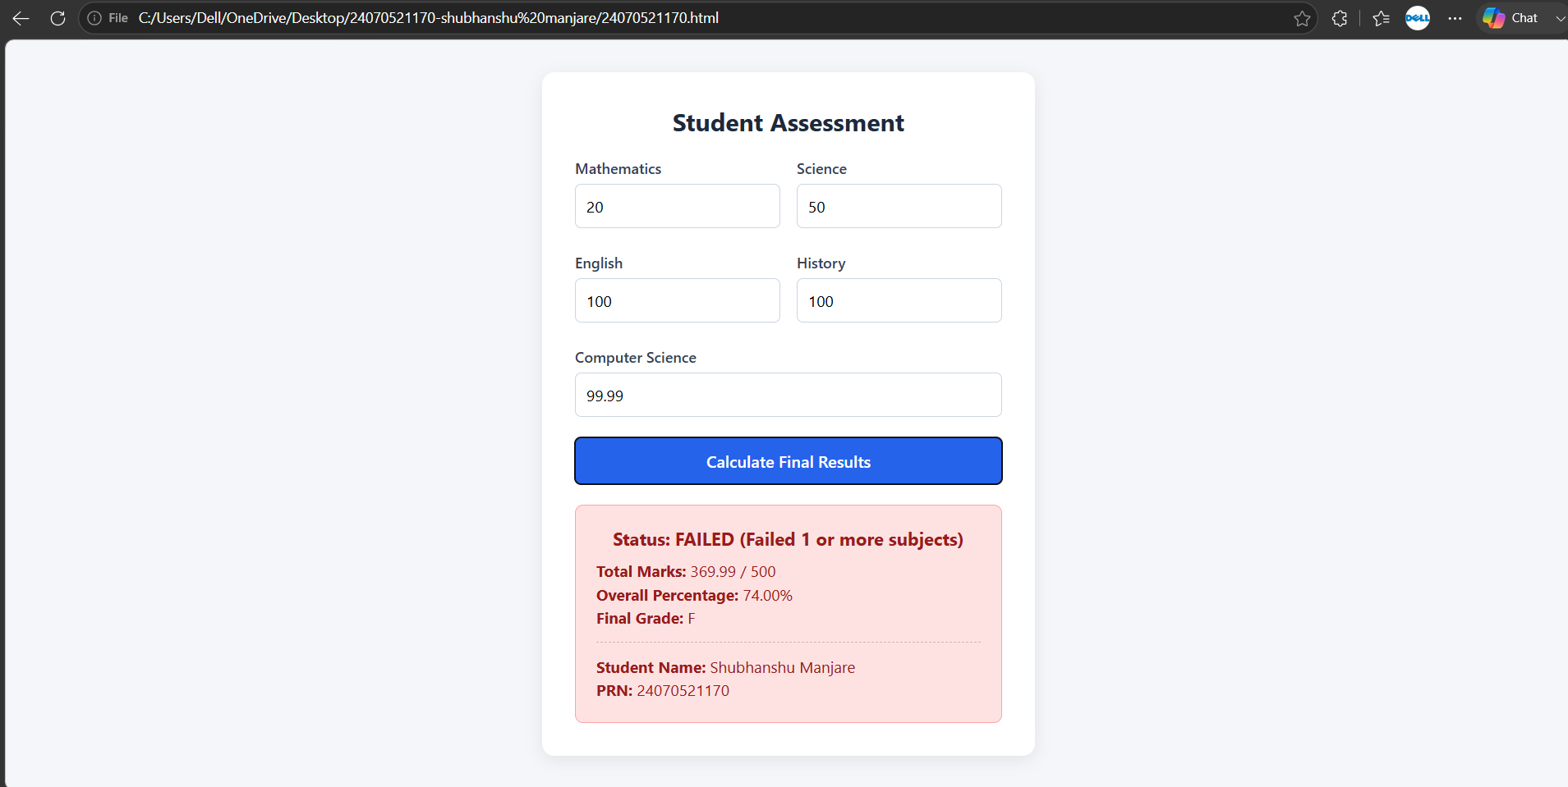

CaseStudy 3
Title: Student Grading System with Login Authentication and Form Validation using HTML, CSS, and JavaScript
Software/Tools Required: HTML5 , CSS3 , JavaScript , Visual Studio Code , Google Chrome
<!DOCTYPE html>
<html lang="en">
<head>
<meta charset="UTF-8">
<meta name="viewport" content="width=device-width, initial-scale=1.0">
<title>Student Login</title>
<link rel="stylesheet" href="style.css">
</head>
<body>
<div class="container">
<h1>🎓 Student Grading System</h1>
<h2>Login Portal</h2>
<form id="loginForm">
<div class="input-group">
<label>Student Name</label>
<input type="text" id="studentName" placeholder="Enter Student Name" required>
</div>
<div class="input-group">
<label>PRN Number</label>
<input type="text" id="prn" placeholder="Enter PRN Number" required>
</div>
<div class="input-group">
<label>Email ID</label>
<input type="email" id="email" placeholder="Enter Email" required>
</div>

<div class="input-group">
<label>Password</label>
<input type="password" id="password" placeholder="Enter Password" required>
</div>
<button type="submit">Login</button>
</form>
<p id="message"></p>
</div>
<script src="login.js"></script>
</body>
</html>

Experiment 4
Title: Use function types, scope, and closures; apply try-catch; build a palindrome checker.
Software/Tools Required: HTML5, CSS3, JavaScript, VS Code, Google Chrome
<!DOCTYPE html>
<html lang="en">
<head>
<meta charset="UTF-8">
<meta name="viewport" content="width=device-width, initial-scale=1.0">
<title>Palindrome Checker</title>
<style>
body{
font-family:Arial,sans-serif;
background:#f4f4f4;
display:flex;
justify-content:center;
align-items:center;
height:100vh;
}
.container{
background:white;
padding:30px;
border-radius:10px;
box-shadow:0 0 10px rgba(0,0,0,0.2);
text-align:center;
width:350px;
}
input{
width:90%;
padding:10px;
margin:15px 0;
font-size:16px;
}
button{
padding:10px 20px;
background:#007bff;
color:white;
border:none;
border-radius:5px;
cursor:pointer;
}

button:hover{
background:#0056b3;
}

#output{
margin-top:20px;
font-size:18px;
font-weight:bold;
}
</style>
</head>
<body>
<div class="container">
<h2>Palindrome Checker</h2>
<input type="text" id="word" placeholder="Enter a word">
<button onclick="checkPalindrome()">Check</button>

<p id="output"></p>
</div>
<script>
// Function Declaration
function cleanText(text){
return text.toLowerCase().replace(/[^a-z0-9]/g,"");
}
// Function Expression
const reverseText=function(str){
return str.split("").reverse().join("");
};
// Arrow Function
const isPalindrome=text=>cleanText(text)===reverseText(cleanText(text));
// Closure
function message(){
let heading="Result : ";
return function(result){
return heading+result;
};}
const displayMessage=message();
// Main Function
function checkPalindrome(){
try{
let input=document.getElementById("word").value;
let output=document.getElementById("output");
if(input.trim()==""){
throw "Please enter a word.";
}
if(isPalindrome(input)){
output.innerHTML=displayMessage("Palindrome ✅");
output.style.color="green";
}
else{
output.innerHTML=displayMessage("Not a Palindrome ❌");
output.style.color="red";
}
}
catch(error){
document.getElementById("output").innerHTML=error;
document.getElementById("output").style.color="orange";
}
}
</script>
</body>
</html>
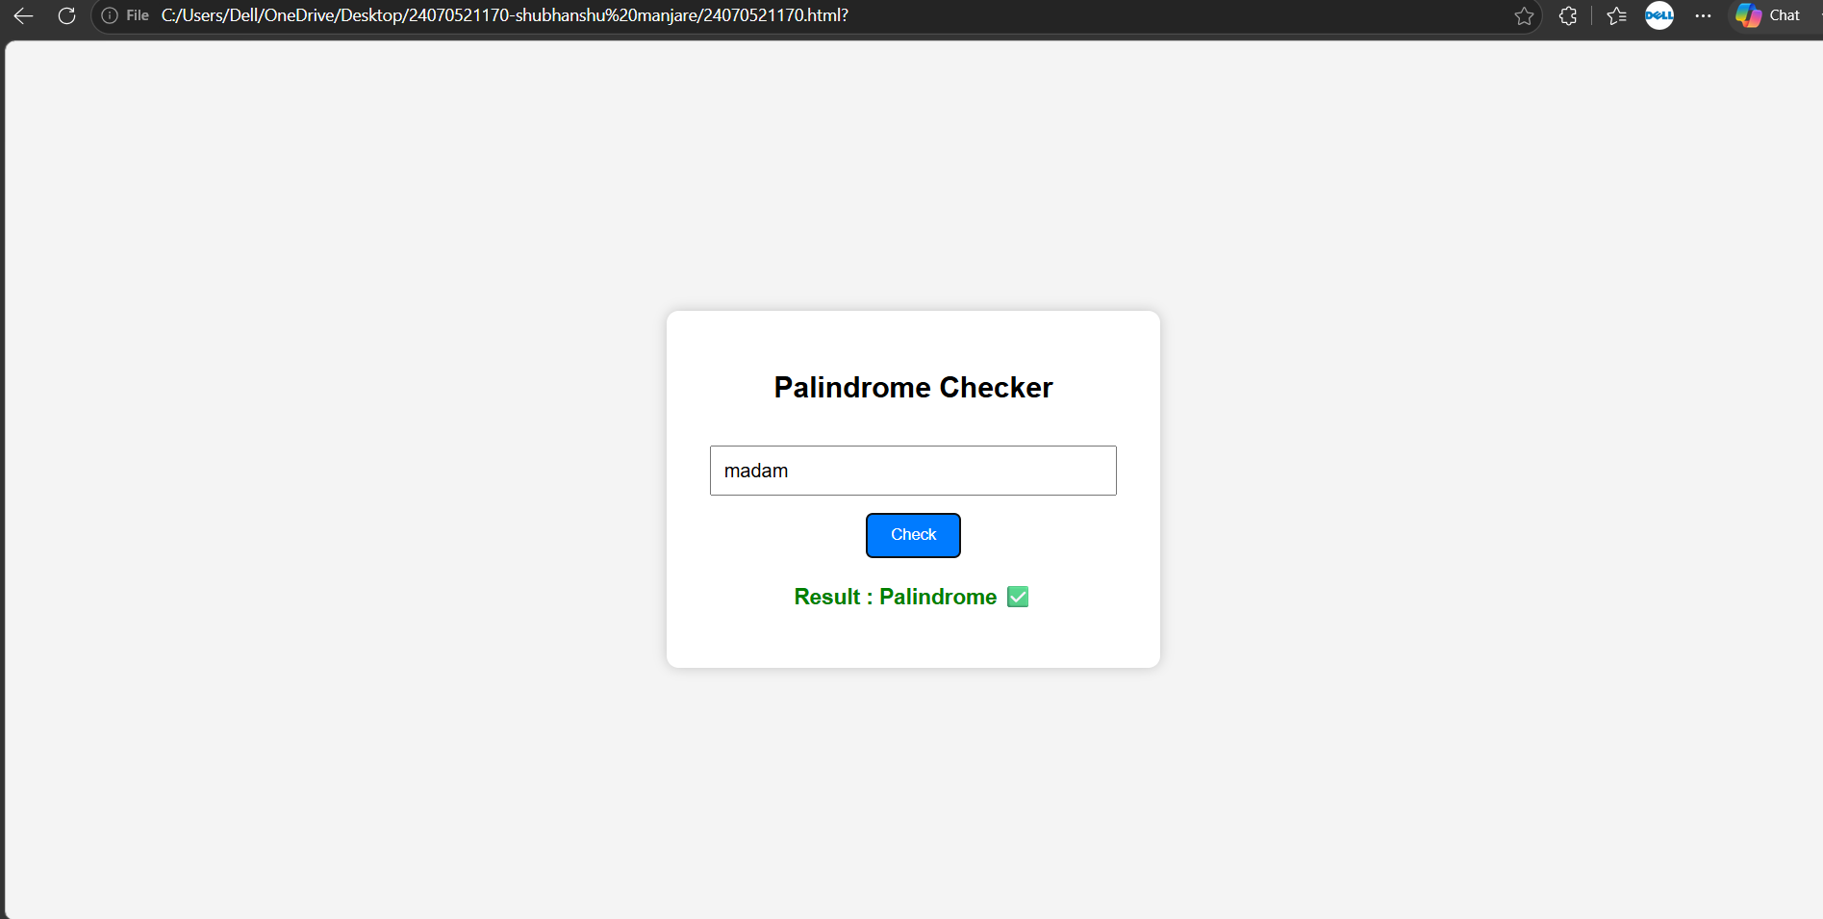
CaseStudy 4
Title: Use function types, scope, and closures; apply try-catch; build a password strength checker using palindrome then display strong or weak password and generate a html and js code.
Software/Tools Required: HTML5, CSS3, JavaScript, VS Code, Google Chrome
<!DOCTYPE html>
<html lang="en">
<head>
<meta charset="UTF-8">
<meta name="viewport" content="width=device-width, initial-scale=1.0">
<title>Smart PIN Security Checker</title>

<style>

*{
margin:0;
padding:0;
box-sizing:border-box;
font-family:'Segoe UI',sans-serif;
}

body{

display:flex;
justify-content:center;
align-items:center;

height:100vh;

background:linear-gradient(135deg,#4facfe,#00f2fe,#43e97b);

}

.container{

width:380px;

padding:35px;

text-align:center;

background:rgba(255,255,255,0.15);

backdrop-filter:blur(18px);
-webkit-backdrop-filter:blur(18px);
border:1px solid rgba(255,255,255,0.3);
border-radius:25px;
box-shadow:0 10px 30px rgba(0,0,0,.25);
}
h2{
color:white;
margin-bottom:10px;

}
p{
color:#f1f1f1;
margin-bottom:20px;
}
.icon{
font-size:55px;
margin-bottom:10px;

}
input[type="text"]{
width:100%;
padding:14px;
border:none;
outline:none;
border-radius:15px;
background:rgba(255,255,255,0.2);
color:white;
font-size:18px;
text-align:center;
margin-bottom:20px;
}
input::placeholder{
color:#eee;
}
button{
width:100%;
padding:14px;
border:none;
border-radius:15px;
background:rgba(255,255,255,0.25);
color:white;
font-size:17px;
cursor:pointer;
transition:.3s;
}
button:hover{
background:white;
color:#0077ff;
transform:scale(1.03);
}
#result{
margin-top:20px;
padding:15px;
border-radius:12px;
font-size:18px;

font-weight:bold;
display:none;
}
.weak{
background:rgba(255,0,0,.2);
color:#ff4d4d;
border:1px solid rgba(255,0,0,.3);
}
.strong{
background:rgba(0,255,100,.2);
color:#00ff88;
border:1px solid rgba(0,255,100,.3);
}
</style>
</head>
<body>
<div class="container">
<div class="icon">🔒</div>
<h2>Smart PIN Security Checker</h2>
<p>Enter your PIN to verify its security level.</p>
<input type="text"
id="pinInput"
maxlength="8"
placeholder="Enter your PIN">
<button onclick="checkPinStrength()">
Check PIN
</button>
<div id="result"></div>
</div>
<script>
function checkPinStrength(){
let pin=document.getElementById("pinInput").value;
let result=document.getElementById("result");
result.style.display="block";
if(pin==""){
result.innerHTML="⚠ Please enter your PIN.";
result.className="weak";
return;
}
// Reverse PIN
let reverse=pin.split("").reverse().join("");
// Extra Conditions
if(pin===reverse){
result.innerHTML="❌ Weak PIN <br>Palindrome PIN detected.";
result.className="weak";
}
else if(pin.length<4){
result.innerHTML="⚠ PIN should contain at least 4 digits.";
result.className="weak";
}
else{
result.innerHTML="✅ Strong PIN <br>Your PIN is secure.";
result.className="strong";
}
}
</script>
</body>
</html>
